ADHICS v2.0 Compliance for Log360
Tagline: Safeguard Abu Dhabi healthcare data with centralized monitoring from Log360.

Overview
The ADHICS v2.0 (Abu Dhabi Healthcare Information & Cyber Security Standard) Compliance extension for Log360 enables Abu Dhabi healthcare organizations and providers regulated by DOH to meet the comprehensive information security and cybersecurity requirements of ADHICS v2.0.
Log360 collects and correlates logs from electronic health record systems, medical devices, cloud platforms, and network infrastructure, providing continuous visibility into patient data access and system integrity. Security and compliance teams can detect threats targeting sensitive health information, demonstrate control effectiveness, and generate audit-ready reports for DOH assessments.

Key Features
- Generate predefined audit reports covering ADHICS v2.0 controls including access management, data confidentiality, and security incident monitoring.
- Track access to electronic health records, detect unauthorized data exports, and monitor privileged user activity across clinical systems in real time.
- Centralize log data from across your infrastructure to maintain real-time visibility into user activity and access patterns, supporting proactive threat identification and compliance posture.
- Export compliance reports in PDF and CSV formats for DOH audits, accreditation submissions, and internal healthcare governance reviews.
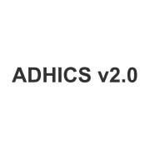
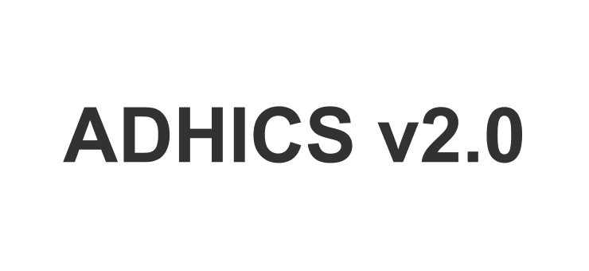

Screenshots
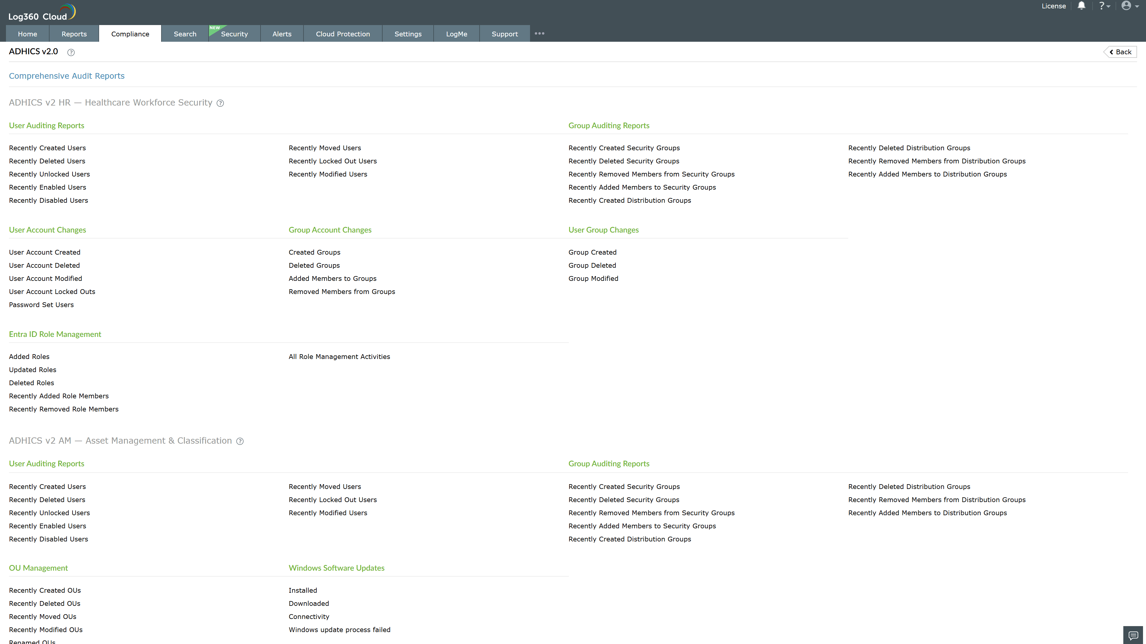
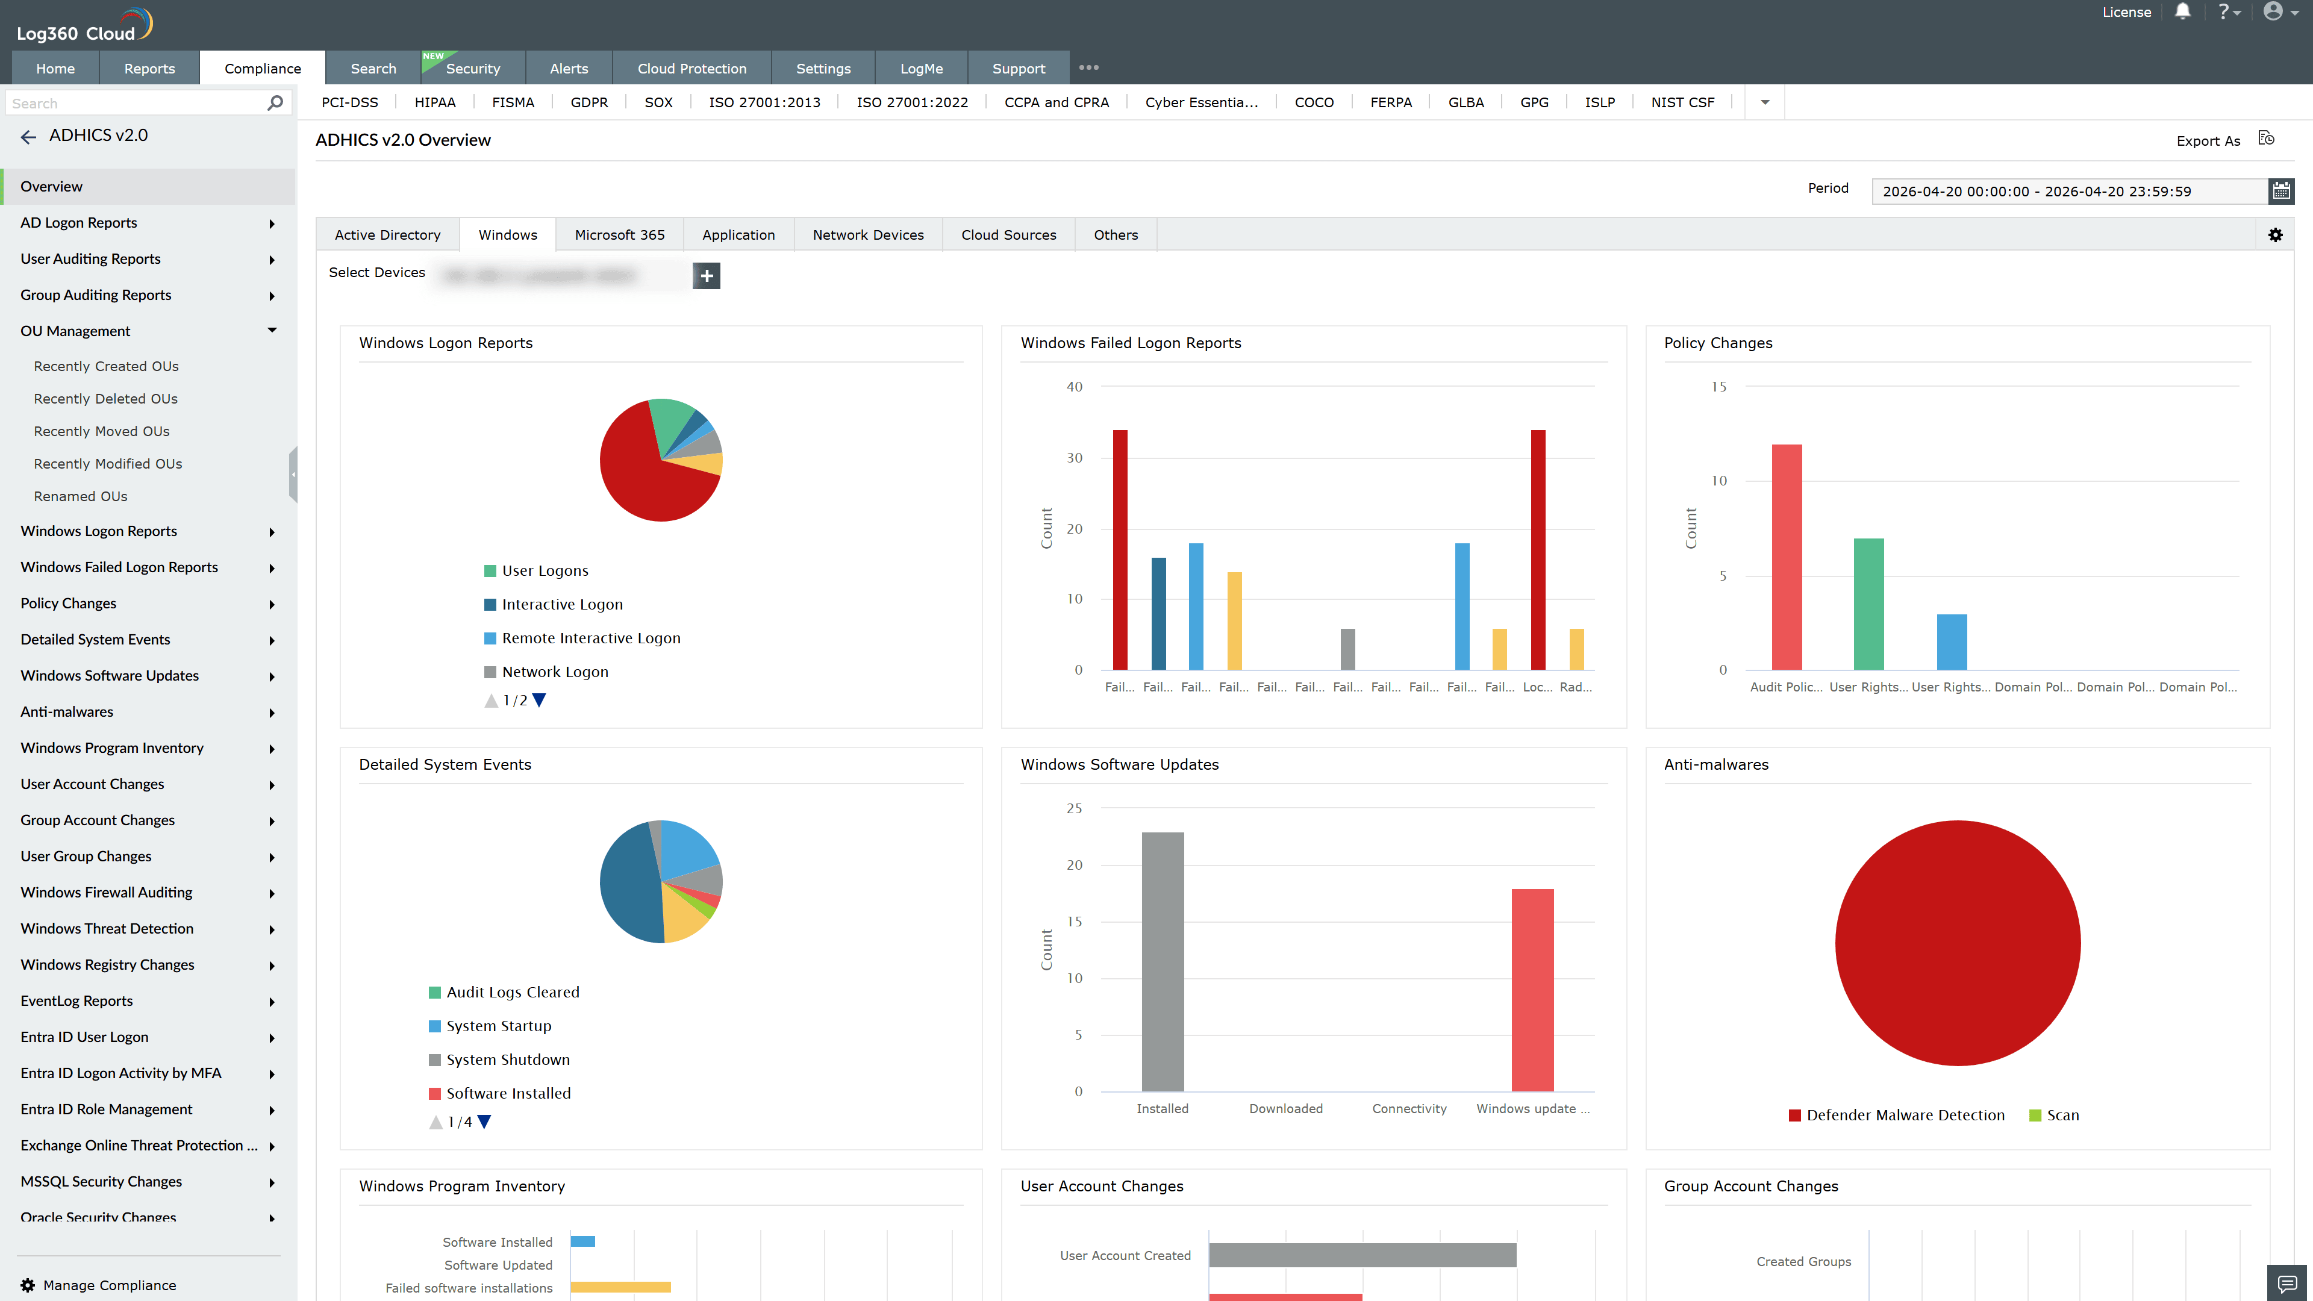
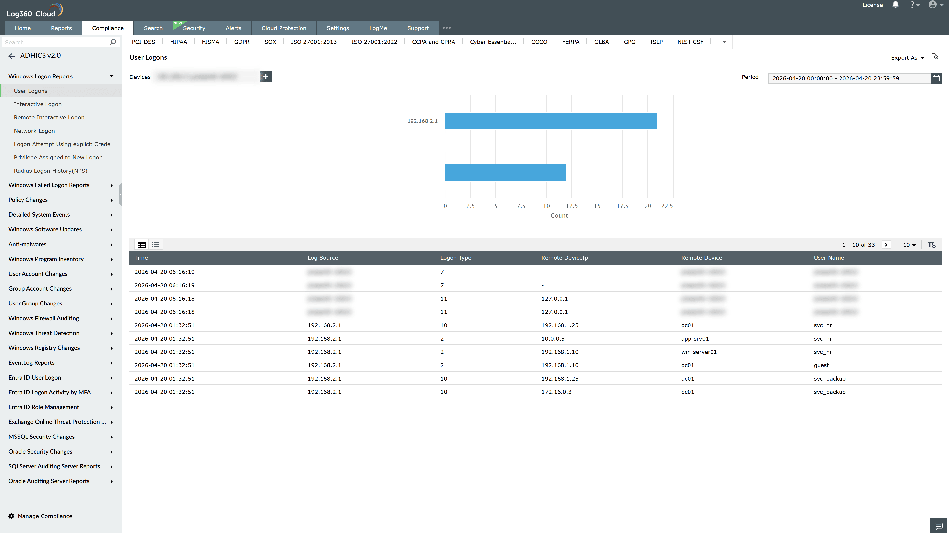
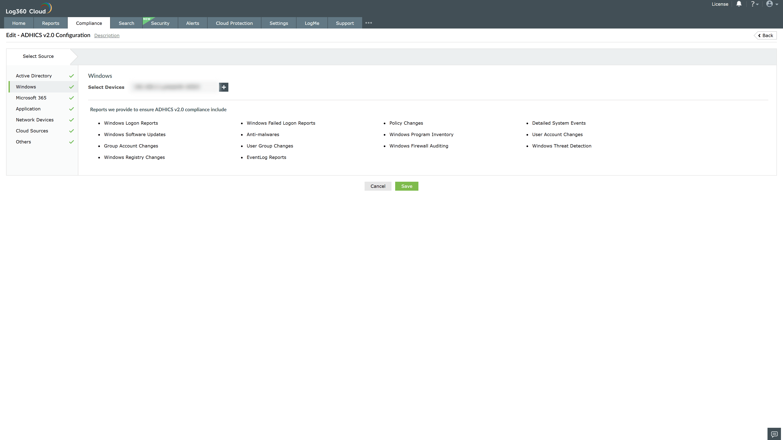

Valid Submission : Yes
Supported Editions : Free, Basic, Standard, Professional, MSSP
Help Document : https://www.manageengine.com/log-management/help/integrations/compliance-extensions.html
Help Video : Not provided
Tags : Log360, Compliance, Privacy monitoring, Data privacy, Regulatory compliance
Supported DCs : US, IN, JP, CA, AU, UK and EU
Privacy Policy:
Terms of Service:
Release Notes:
Predefined reports for the ADHICS v2.0 Compliance

